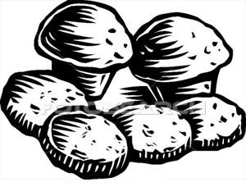
Pumpkin Muffins
Ingredients
Wet mix
¼ cup margarine
½ cup sugar
2 eggs
1 cup pumpkin puree---cook 300g pumpkin in ¼ cup water (mash with potato masher or puree in blender)
Dry mix
2 ½ cups self raising flour
Topping
1 tablespoon sugar / 1 tablespoon cinnamon aprox
Equipment
Large bowl
Masher/blender
Measuring cups, measuring spoons
Electric hand beater
Chopping board vegetable knife
Spatula
Method
Cut, peel and chop pumpkin, cook in water till soft. Puree. Cool
Pre-heat oven and place patty cases in tin
Beat margarine and sugar till creamed , sugar needs to be dissolved into mixture-changes color
Add eggs one at a time beating well after each addition
Add pumpkin, mix
Fold flour into wet mix and place in patty cases
Sprinkle with topping
Makes 10
Bake 180 C for 15-20 min

