Stephanie Alexander
Kitchen Garden Cooking Program
Home Economics Teacher Vickie Richards

Silver beet Fritter
Utensils
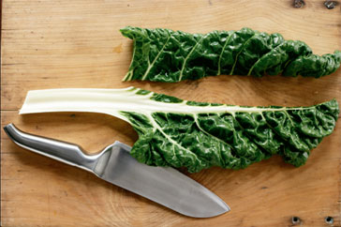Chopping Board
Vegetable Knife
Egg flip
Fry pan
Electric hand beater
½ measuring cup
Medium bowl
Spoon

Ingredients
1 Tablespoon finely chopped onion
1/2 cup milk aprox to make thick batter
2 large leaves silver beet
½ teaspoon salt
1 Egg
¼ cup corn
½ cup S/R Flour
Olive Oil
makes 12

Method
- Thinly slice silver beet
- Finely chop onion
- Beat egg with flour and milk lightly in medium bowl
- Add all ingredients except olive oil into mixture. Mix well
- Heat oil in fry pan on medium – spoon small mounds into fry pan cook slowly and brown both sides

Serve

