Watermelon, Mint and Fetta Salad
INGREDIENTS
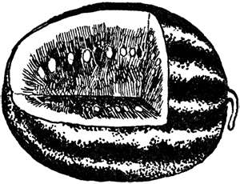
2 TEASPOONS WHITE SUGAR
1/4 CUP LIME JUICE
1/2 CUP CRUMPLED FETTA CHEESE
1/2 SMALL RED ONION
1/2 CUP CHOPPED FRESH MINT
850G WATERMELON CUT INTO WEDGES
EQUIPMENT
chopping board
vegetable knife
measuring spoons, measuring cups
cooks knife , measuring jug
medium bowl
METHOD
1. Dissolve sugar in jug with juice.
2. Cut watermelon into wedges, remove skin and place on serving plate.
3. Chop mint.
4. Slice red onion thinly.
5. Crumble fetta into bowl.
6. Place juice, sliced red onion and chopped mint into bowl with cheese .
7. Spoon over watermelon, serve.

